The Ultimate Newsletter About Page Template
The 5-Part Framework Behind Standout Newsletters
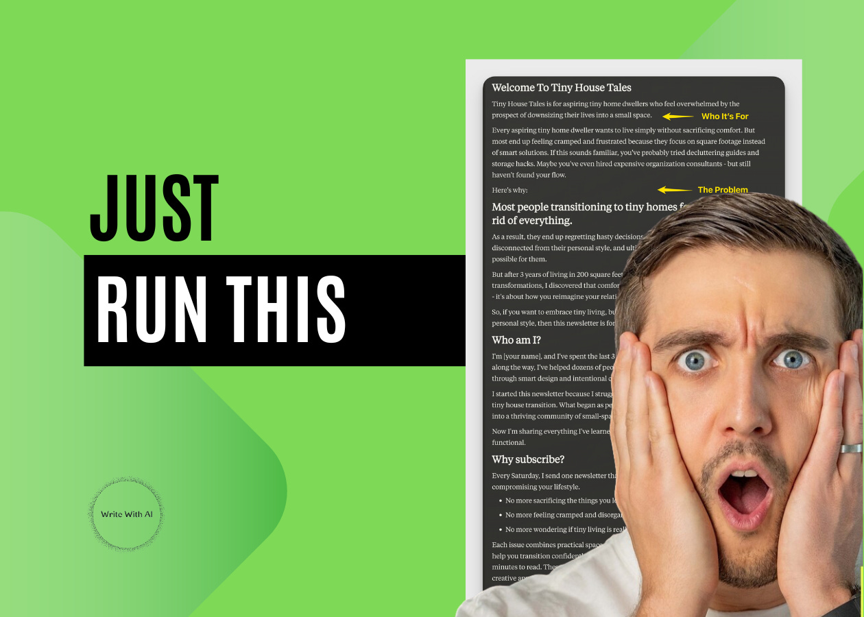

Your newsletter About page has 2 very important jobs:
- Convince your reader why they should stay
- Get them to subscribe
Unfortunately, most creators get this backwards.
Instead of focusing on the reader's needs, they write a mini autobiography. They share their entire career path, personal journey, and every credential they've ever earned.
Your About Page Isn’t About YOU
Think about the last time you discovered a newsletter online.
Maybe someone shared it on X, or you saw it mentioned in an article. The name catches your attention. So, you click through, scan a few sample issues, then land on their About page—where you make your decision.
And you want to know one thing, “What will this newsletter do for me?”
It’s here where most creators lose potential subscribers. But if you can clearly position your newsletter as a solution to their problem, they’re much more likely to stick around.
5 Steps to Transform Your Newsletter About Page From “About Me” Into “Subscribe Now”
Here’s how to do it:
1. Lead With Your Reader’s Problem
Readers want to know what problem your newsletter solves for them.
In 2-3 sentences, describe the challenge they’re facing, then explain how your newsletter helps overcome it. Focus on transformation rather than just information. This builds an emotional connection—and that’s what turns a reader into a subscriber.
Bad example:
"I share parenting tips."
Good example:
"There’s a lot of bad parenting advice out there. Like really bad. If you spend just half a minute on parenting Instagram, you are bound to start feeling like a failure because all the so-called parenting experts are telling you that there’s only one way to do X, Y or Z and that if you don’t do it their way, you’re going to screw up your child. ‘Is My Kid the Asshole?’ empowers parents, rather than scares them.”
Positioning your newsletter as the solution makes the benefit clear right away.
2. Define Who Your Newsletter Is For
Your newsletter isn’t for everyone—and that’s a good thing.
The clearer you are about who your content is really for, the more your ideal readers will see themselves in it. And the ones who aren't a fit? They'll self-select out, which saves you time.
- Don’t say: “This newsletter is for anyone interested in SaaS.”
- Do say: “This newsletter is for early-stage founders sick of chasing venture capital and ready to bootstrap their way to $1M ARR.”
- Don’t say: “I write for people transitioning to tech.”
- Do say: “I write for mid-career professionals who want to break into tech without starting over at an entry-level salary.”
You’re not just defining your audience—you’re filtering it.
Be specific enough to call out exactly who will benefit most and who should skip it.
3. Show Why You’re Worth Their Trust
Now, you can talk about yourself.
Pick 2-3 specific proof points that directly relate to your newsletter's topic. But keep it relevant. Stay focused on the benefits for your audience. This will draw them in and help them feel a connection.
For example:

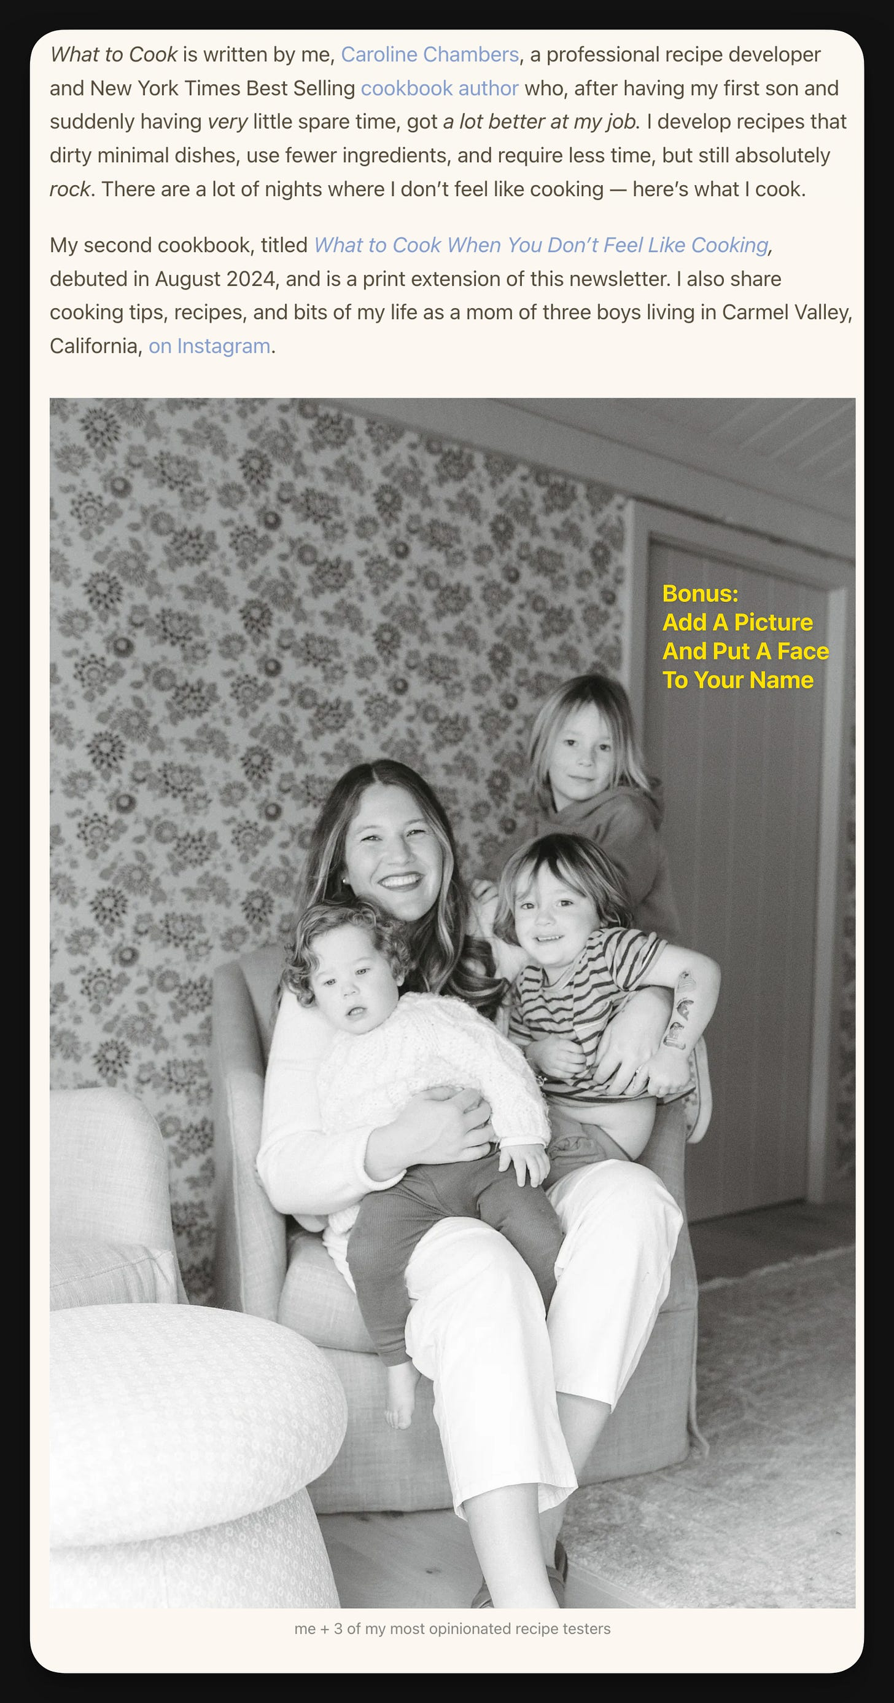

Caroline’s introduction is clear, focused on experience, and relevant to the value of the newsletter.
A few tips:
- Include why you started the newsletter in 1-2 sentences.
- Highlight any accomplishments.
- Add a testimonial from happy readers.
- Share data on your open rates or subscriber count.
- If you have a powerful origin story—this is where to mention it.
Your audience is looking for results.
They want to know why you’re the one who can help them.
4. Highlight The Benefits Of Subscribing
People like knowing what they’re signing up for.
Spell out exactly what your subscribers will get and how often:
- “New issues drop every Wednesday and Friday including case studies, growth hacks, and email optimization tips.”
- "Paid subscribers receive an exclusive recipe drop every single Saturday morning, and can access all past recipes on the website. Unpaid subscribers receive a recipe drop once a month, along with free previews of the new recipes."
- "Every week, we send a new Digital Writing framework & ChatGPT / AI prompt straight to your inbox. As a paid subscriber, you’ll get everything we've ever posted—frameworks, templates, and insider writing tips."
The more specific you are about what the reader will receive, the more likely they are to understand the value. This clarity makes the decision to subscribe easier.
5. Make Your Call-to-Action Crystal Clear
Don’t leave your reader wondering what to do next.
End with a clear and direct call-to-action.
- "Get the next issue in your inbox this Sunday"
- "Join 50,000+ readers getting smarter about Gluten Free living"
- "Start with our most popular edition: How to know if you’ve got product-market fit"
- "If you’re serious about learning how to make a living as a digital writer, hit subscribe and join thousands of writers who are already leveling up their careers."
Whether you want them to subscribe or explore past issues, make the next step obvious and easy.
By structuring your About page this way, you’re positioning your newsletter as the solution to your reader’s problems and making it easy for them to see the value of subscribing.
13 Newsletter About Page Examples

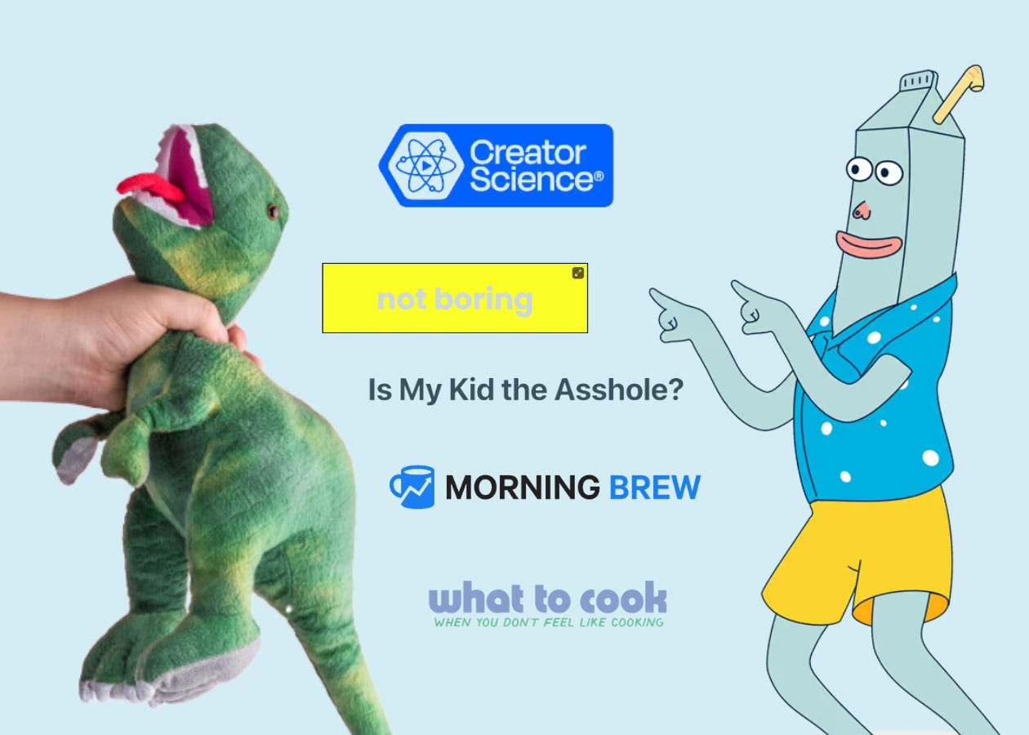

To give you a clearer picture of how this looks in action, here are a few standout examples from creators who get it right.
- Milk Road
- Not Boring
- Morning Brew
- Write With AI
- Below the Fold
- Dickie’s Digest
- Creator Science
- For The Interested
- The 3-2-1 Newsletter
- Is My Kid The Asshole?
- The Saturday Solopreneur
- The Art & Business Of Writing
- What To Cook When You Don’t Feel Like Cooking
Each of these newsletters takes a unique approach to their About page, mixing and matching the components we covered.
Some are brief while others are more detailed. The order may vary and certain elements might be emphasized more than others. However, look closely and you'll notice they all incorporate the key principles.
Even the shortest About pages hit these essential notes in their own way.
The Ultimate Newsletter About Page Template
Now that you've seen how these creators structure their About pages, you can apply the same principles to yours.
Here’s a template to get started:
# Welcome To [Newsletter Name].

[Newsletter Name] is for [target audience] who [pain point].

Every [target audience] wants to [desired outcome]. But most end up [negative outcome] because [reason]. If this sounds familiar, you've probably tried [related solution #1] and [related solution #2]. Maybe you've even [expensive/time-consuming solution] - but still haven't seen results.

Here's why:

# Most [target audience] in [field] focus on [flawed approach to desired outcome].

As a result, they end up [related negative consequence #1], [related emotional consequence #2], and [related ultimate negative consequence #3].

But after [timeframe] of [activity/research], I discovered that [contradictory insight that directly addresses the above problems].

So, if you want [desired skill], but also [common obstacle] to [desired outcome], then this newsletter is for you.

# Who am I?

I'm [name], and I've spent [X years/time period] [doing specific thing], and along the way, I [key insight/specific achievement/milestone].

I started this newsletter because [personal story/motivation/problem you solved for yourself]. What began as [humble beginning] has grown into [what it is today/what you've learned].

Now I'm sharing everything I've learned about [topic].

# Why subscribe?

Every [frequency], I send one [content type] that helps you [main benefit] without [major pain point].

- No more [common frustration #1].
- No more [common emotional frustration #2].
- No more [ultimate negative frustration #3].

Each issue combines [content type 1] and [content type 2] to help you [main benefit], delivered in a [tone/style] format that takes just [X] minutes to read. These [content type]s don't [common compromise], but instead [unique approach] to help you [desired outcome] in [timeframe/constraint].

I cover everything from [Topic #1], to [Topic #2], to [Topic #3]. Not only do you get [what most people expect], but each issue also comes with the following:

- [Unique aspect #1]

- [Unique aspect #2]

- [Unique aspect #3]

My goal is for you to find something worth reading in every single edition.

And my promise is [your promise] because [reason].

# Ready to [achieve desired outcome]?

Click here to [call to action with social proof].
There are two ways you can apply this template:
- Use it as a guide and fill in your details manually.
- Run it as a prompt and let Claude fill in the blanks for you.
Let’s walk through how to run it as a prompt step-by-step.
Step 1: Introduce Claude To Your Newsletter
Start by telling Claude about your newsletter and what you want to achieve with the About page.
Use this prompt:
“Hey Claude, I want to write an About page for my [newsletter name] newsletter. It’s for [target audience], and it helps them [problem your audience faces] by providing [type of content or solutions you deliver]. I’ve [mention your experience, credentials, or proof points], and I send issues [frequency].
I am going to give you a template and I want you to fill it in for me.
Do you understand?”

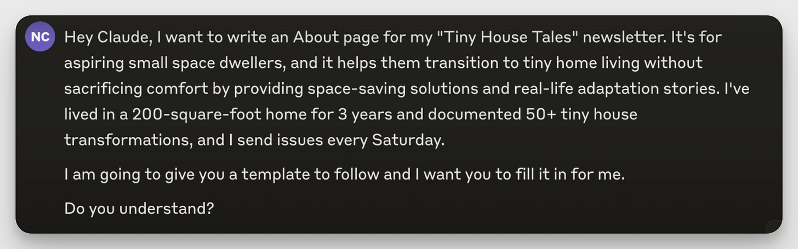

This gives Claude the context needed to write a focused About page draft tailored to your audience and content.
Step 2: Feed Claude The Ultimate About Page Template (And Watch It Come To Life In 2.5 Seconds)

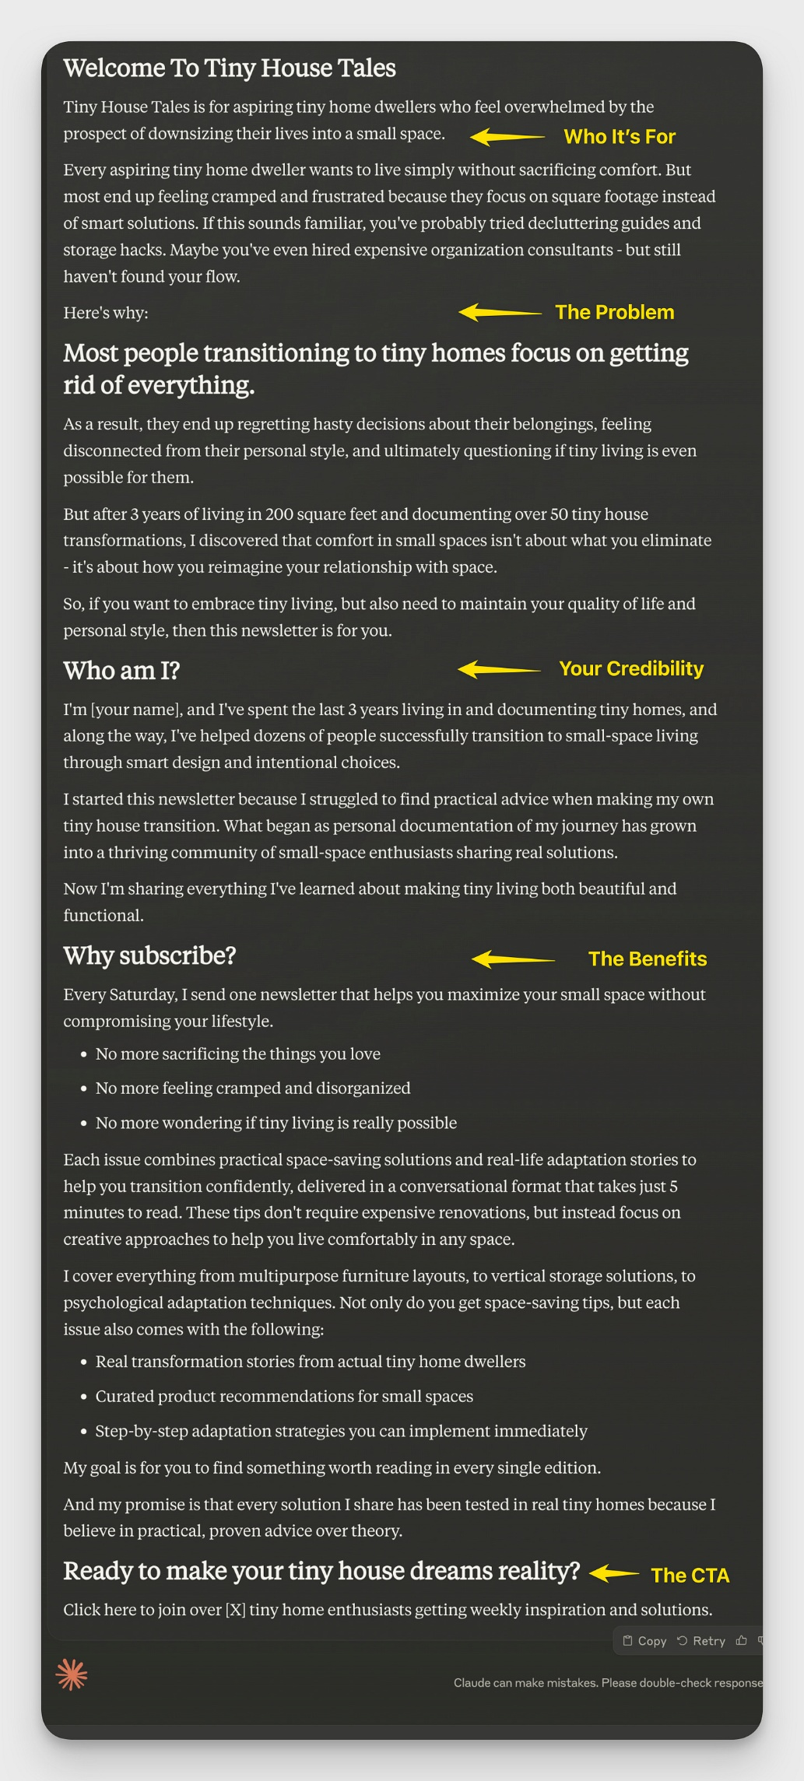

Step 3: Review And Edit Claude’s Draft
Claude will generate a draft based on the information you’ve provided.
Simply copy and paste the draft into your newsletter About page, and make any final edits to ensure it matches your tone and style.
That’s it.
Remember: Every element of your About page should push readers to hit the subscribe button while positioning your newsletter as the solution to their problem. If something doesn't serve that goal, cut it.

